Chapter 3 Question 6 - Michael Streyle

##   
## Call:  
## lm(formula = hardness ~ time)  
##   
## Residuals:  
## Min 1Q Median 3Q Max   
## -5.1500 -2.2188 0.1625 2.6875 5.5750   
##   
## Coefficients:  
## Estimate Std. Error t value Pr(>|t|)   
## (Intercept) 168.60000 2.65702 63.45 < 2e-16 ***  
## time 2.03438 0.09039 22.51 2.16e-12 ***  
## ---  
## Signif. codes: 0 '***' 0.001 '**' 0.01 '*' 0.05 '.' 0.1 ' ' 1  
##   
## Residual standard error: 3.234 on 14 degrees of freedom  
## Multiple R-squared: 0.9731, Adjusted R-squared: 0.9712   
## F-statistic: 506.5 on 1 and 14 DF, p-value: 2.159e-12

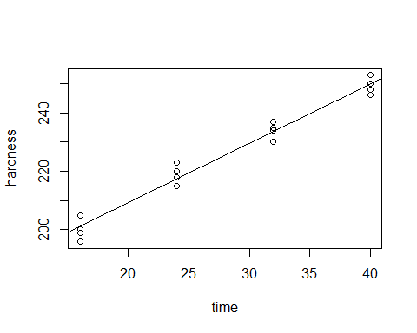

##   
## R SQUARED:

## [1] 0.9731031

##   
## CORRELATION COEFFICIENT:

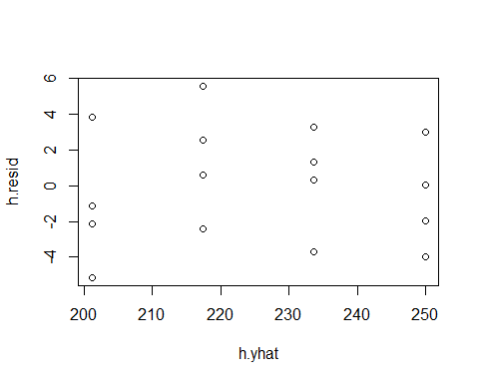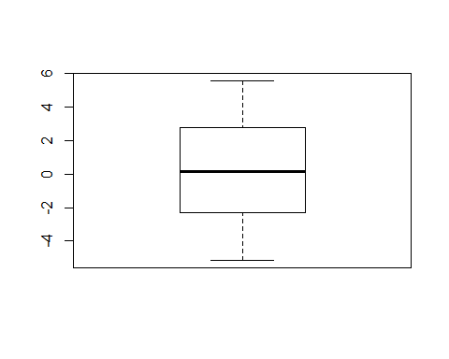## [1] 0.9864599

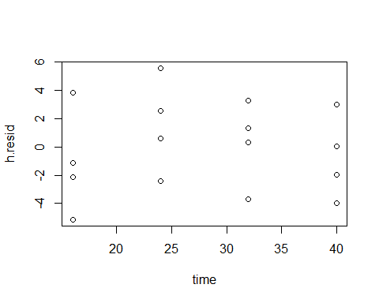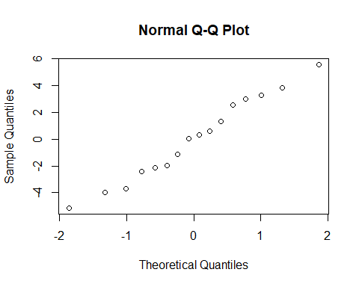

Chapter 3 Question 6

Written Out Answers

1. The residuals are 1 2 3 4 5 6 7 8 9 10 11 12

-2.150 3.850 -5.150 -1.150 0.575 2.575 -2.425 5.575 3.300 0.300 1.300 -3.700

13 14 15 16

0.025 -1.975 3.025 -3.975.

See knitted section for boxplot. It shows the spread of the residuals which appears to show constant variance and a normal spread.

1. See the knitted section for the graph of residuals against the fitted values Ŷ. Based on this plot, there doesn’t seem to be any outliers. Since the residual values are relatively evenly spread out between -4 and 4, the maximum and minimum values are not extreme enough to be considered outliers. If the plot was of semistudentized residuals, then the rule of thumb is if the absolute value of any residual is greater than 4, then it can be considered an outlier, however this plot of just of the simple residuals.
2. See knit section for the normal probability plot of the residuals (Normal Q-Q Plot). The normality assumption does appear to be reasonable. When compared to the plots on page 112 of the book, this plot does not have any of the departing from normality trains.